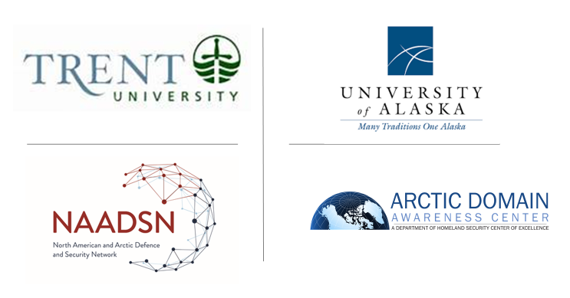
Guidance for Presentations
17-18 September 2020 Advancing Collaboration in Canada-U.S. Arctic Regional Security (ACCUSARS)

As of 13 Sep 2020

Introduction:

Two Arctic research-focused teams, the Arctic Domain Awareness Center (ADAC), a U.S. Department of Homeland Security Center of Excellence in Maritime Research, who is hosted by the University of Alaska Anchorage, and the North American and Arctic Defence and Security Network, (NAADSN) who is hosted by Trent University, in Peterborough Ontario, are seeking to advance a baseline understanding of the current state of security in the Arctic. This baseline will allow further investigation into the complex risks affecting the North American Arctic.

Respectful guidance:

The following is the Presenter Guidance (along with supporting information for ADAC and NAADSN’s 2020 “Advancing Collaboration in Canada-U.S. Arctic Regional Security (ACCUSARS)” workshop planned for 17-18 Sep 2020, via Zoom.

Note as a virtual conference that contains both Plenary and Breakout group sessions, please note, presentations are only conducted in the Plenary format.

ACCUSARS is a working level meeting that is focused on practical discussions and meaningful content. The expert presentations are respectfully requested to be informal and presented in a manner most comfortable to the presenter.

As such, viewgraphs/slides are completely at the discretion of the presenter. If viewgraphs are desired, workshop planners respectfully request a target range of 3-5 viewgraphs that have readily readable fonts (in Microsoft Powerpoint, this normally means a minimum font size of 20). Script or other hard to read fonts are respectfully discouraged.

Workshop hosts will provide the presenter the option to present the slides themselves (via share screen) or the hosts will present on behalf of the presenter. In order to accommodate the presenter’s sharing a screen, workshop planners will make each presenter a “co-host” to the Zoom conference call for the duration of the presentation.

If the presenter desires to have the workshop planners present, please presentations to the following addresses not later than Close of Business, Tuesday, 15 Sep 2020.
To: rakee@alaska.edu and pwhitneylackenbauer@trentu.ca

Cc copy to: jtroe2@alaska.edu, ematthews@alaska.edu, and shannonnash@trentu.ca

The following are the requested/suggested focus areas and presentation times for each presenter for the workshop. Workshop planners are mindful that each presentation time frame is constrained, but overall, the intent for most of the discussions should feel more as a survey or a set of higher-level observations, as opposed to an in-depth or deep dive dialogue.

Day 1 (17 Sep 2020)

0810-0930: The Confluence of Canadian and U.S. Arctic Security Interests
Opening remarks by Commander Alaska Command, Alaska NORAD Region and 11th Air Force, Workshop planners respectfully request planned remarks at approximately 15 minutes duration.
Panelists: Each speaker is requested to present at approximately 8-10 minutes, duration, leaving approximately time for 1-2 questions at the end. Workshop planners note, participants normally are reluctant to ask questions of VIP presenters, particularly early in the workshop.
Focus areas: This panel will provide workshop participants a current focus by panelists from their personal and professional view on the challenges, concerns and opportunities to improve security and defense of North America’s “Northernmost Border” security. Workshop planners encourage the presenters to consider…what is working, what is missing and what is needed…whether it is policy, authorities, planning, capabilities or resourcing?
0940-1040: The Arctic Security Environment: Deepening, Broadening, and Sharpening our Strategic Analysis
Panelists: Each speaker is requested to present at approximately 5-7 minutes, duration, leaving approximately time for 2 questions at the end.
Day 2 (18 Sep 2020)
0840-0950 The Homeland is Not a Sanctuary: Capabilities and Strategic Messaging (roundtable)
Panelists: Each speaker is requested to present at approximately 5-7 minutes, duration, leaving approximately time for 2 questions at the end.
Focus areas: Panelists are asked to address the shifting power dynamics in the Arctic in terms of Great Power Competition, and friction points to mitigate from otherwise partners and allies in addressing CANUS North American Arctic security. How do Canada and the U.S. conceptualize these dynamics as potential security risks or threats through, to, and in the North American Arctic?
0945-1040: Operational Insights: Gaps, Seams, and Best Practices (roundtable)
Panelists: Each speaker is requested to present at approximately 8-10 minutes, duration, leaving approximately time for 2 questions at the end.
Focus areas: Briefly examinee the roles of land, sea, air, and/or special operations forces, as well as other government departments/agencies, in demonstrating sovereignty, enforcing laws, and exercising deterrence against activities that undermine or threaten to undermine CANUS interests in the North American Arctic. What forms and level of surveillance are required? How do we operate in this environment to achieve these effects? How can CANUS practitioner’s better share “best practices”? In sum…what is working, what is missing and what is needed…whether it is policy, authorities, planning, capabilities or resourcing?
Please know how much the workshop planners are appreciative of the efforts by the presenters to provide your incredibly important and invaluable experience to the workshop presenters.

Sincerely,

The UA Arctic Domain Awareness Center Team, and

The North American Arctic Defence and Security Network Team

